**To install JMS:**

Download activemq zip from Apache

<http://activemq.apache.org/download.html>

Unzip e.g., to C:\Program Files folder

[run “zip tool” as Administrator]

**RUN via Command Line:**

To open CMD line window with Administrator privileges:

Start/Search box: type cmd, and then press CTRL+SHIFT+ENTER[For ADMIN privileges]

TO RUN:

At CMD line : cd to install folder [ e.g., cd C:\Program Files\activemq]

then : bin\activemq [add “start” to cmd line if 5.10 or higher]

**RUN as Service:**

Here are the steps to install the ActiveMQ broker as an NT service:

1. Download the windows binary distribution (i.e. apache-activemq-5.15.9.zip)
2. Go to /bin/win32
3. Run InstallService.bat

To see Queues:

<http://localhost:8161/admin/queues.jsp>

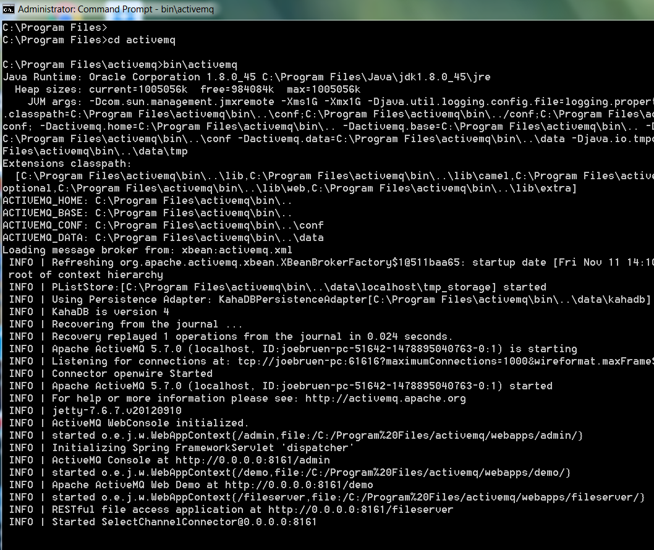

**NOTE: There ALSO can be a port conflict between activeMQ & RabbitMQ -**

**port conflict issue between AMQP and JMS:**

**go to activemq\conf folder**

**open activemq.xml file and search for:**

**"<transportConnector name="amqp" uri="amqp://0.0.0.0:5672?"**

**Change the port #: 5672 to another number, for example 5000**